Metoda pentru counter sarituri verticale si cum calculez distanta sarita
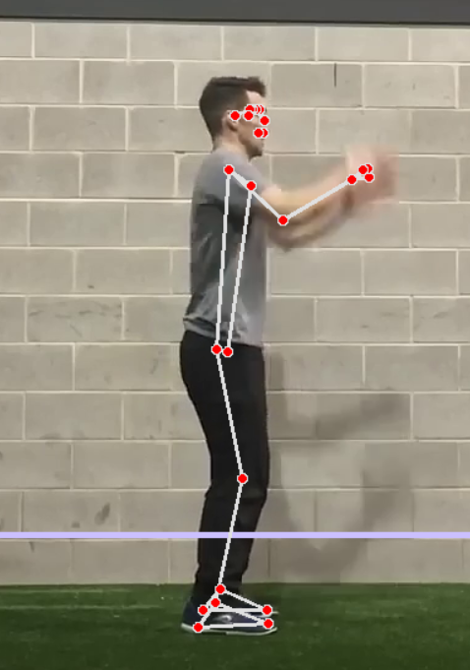 | 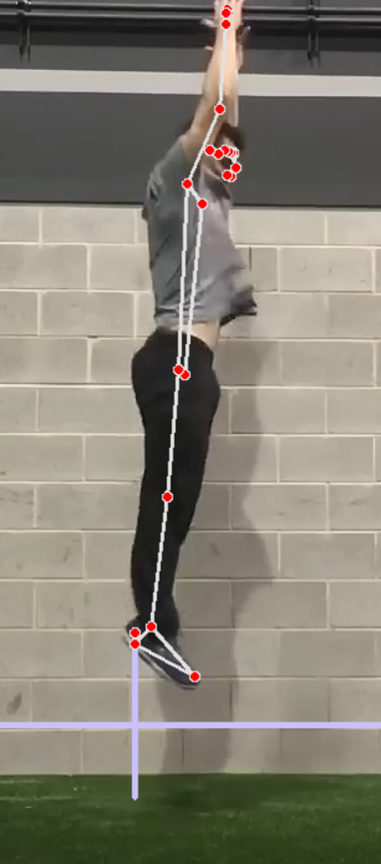
Algoritm folosit pentru keypoints:
- mediapipe
Metoda pentru detectare saritura:
Pentru a determina daca o saritura a fost realizata, verific daca coordonatele calcaielor picioarelor sunt mai sus (mai mici in coordonate) decat linia de pe ecran (linie care e trasata la jumatatea coordonatelor y ale calcaielor si ale genunchilor).

Verificarea unei sarituri corecte:
#TO DO: de verificat in cod si modul cum sare atletul. (balans al mainilor in sus si jos, inainte de saritura se indoaie genunchii)
“the athlete starts from a standing position and initiates a downward movement, which is immediately followed by an upward movement leading to takeoff. In contrast, during the SJ, the athlete descends into a semi-squat position and holds this position for approximately 3 seconds before takeoff. The performance of a movement with countermovement is almost always better than a movement without countermovement when there is no time-pressure present “
Sursa: cris.maastrichtuniversity.nl/ws/files/35843776/Hooren_2017_Difference_Between_Countermovement.pdf

Calculul distantei sarite:
Pentru a calcula distanta sarita in metri, am realizat o aproximare. Am determinat inaltimea atletului in pixeli (folosind landmark-urile de la calcai pana la cel mai inalt punct al fetei – ochii). Cunoscand inaltimea reala a atletului in metri (furnizata la crearea contului), am calculat raportul dintre cele doua valori si l-am inmultit cu inaltimea sariturii in pixeli. Rezultatul obtinut reprezinta inaltimea sariturii in metri.
def calculateHeightJump(self):
self.jumpHeight_px = self.legsOnFirstFrame[1] - self.prevCoord
self.listOfJumps.append(pxToM(self.athleteHeight, self.jumpHeight_px, self.athleteHeight_px))
def pxToM(athleteHeight_m, aux, athleteHeight_px):
return (athleteHeight_m * aux) / athleteHeight_px

Rezultate:
